Sinh viên thực hiện: Hồ Anh Nam

FIle báo cáo thực hành

**Mục lục**

BÀI 1. NHÁY LED 2

1.Mô tả 2

2. Sơ đồ thiết kế 2

3. Mã lệnh 2

Bài 2. Nháy Led có nút bấm 3

1. Mô tả 3

2. Sơ đồ thiết kế 3

Bài 3. LED sáng dần 4

1. Mô tả 4

2. Sơ đồ mạch 4

3. Mã Lệnh 4

Bài 4. LED sáng dần từ LED số 1 – 10 5

1. Mô tả 5

2. Sơ đồ mạch 5

3. Mã lệnh 5

Bài 5. LED RGB 6

1. Mô tả 6

2. Sơ đồ mạch 6

3. Mã lệnh 7

Bài 6. Cảm biến nhiệt độ điều khiển độ sáng của LED 8

1. Mô tả 8

2. Sơ đồ mạch 8

3. Mã lệnh 9

BÀI 1. NHÁY LED

1.Mô tả

- Led tự động nháy đèn led sau khoảng thời gian 1 giây. Led được đấu vào cổng 13 của Board

2. Sơ đồ thiết kế

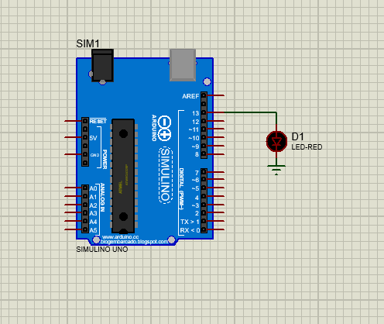

3. Mã lệnh

|  |  |  |  |  |  |  |  |  |  |  |  |  |  |  |  |  |  |  |  |  |  |
| --- | --- | --- | --- | --- | --- | --- | --- | --- | --- | --- | --- | --- | --- | --- | --- | --- | --- | --- | --- | --- | --- |
| |  | | --- | | Int pin=13; | |  | void setup(){ | |  | pinMode(13,OUTPUT); | |  | } | |  |  | |  | void loop(){ | |  | digitalWrite(13,HIGH); | |  | delay(500); | |  | digitalWrite(13,LOW); | |  | delay(500); | |  | } | |

Bài 2. Nháy Led có nút bấm

1. Mô tả

* Led sáng sau khi nhấn vào nút bấm

1. 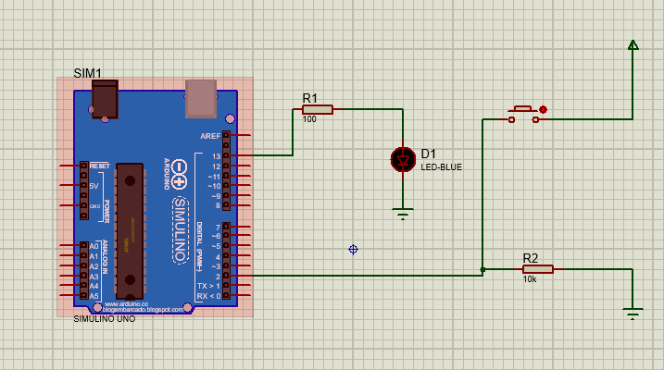Sơ đồ thiết kế
2. **Mã Lệnh**

|  |  |  |  |  |  |  |  |  |  |  |  |  |  |  |  |  |  |  |  |  |  |  |  |  |  |  |  |  |  |  |  |  |  |  |
| --- | --- | --- | --- | --- | --- | --- | --- | --- | --- | --- | --- | --- | --- | --- | --- | --- | --- | --- | --- | --- | --- | --- | --- | --- | --- | --- | --- | --- | --- | --- | --- | --- | --- | --- |
| |  |  | | --- | --- | | int x = 0; | | |  | void setup() { | |  | // put your setup code here, to run once: | |  | pinMode(2, INPUT); | |  | pinMode(13, OUTPUT); | |  | } | |  |  | |  | void loop() { | |  | // put your main code here, to run repeatedly: | |  | x = digitalRead(2); | |  |  | |  | if( x == HIGH) { | |  | digitalWrite(13, HIGH); | |  | } else { | |  | digitalWrite(13, LOW); | |  | } | |  | } | |

Bài 3. LED sáng dần

1. Mô tả

* Sau khi cấp nguồn điện, đèn led sáng dần rồi tắt và cứ thế lặp lại

1. Sơ đồ mạch

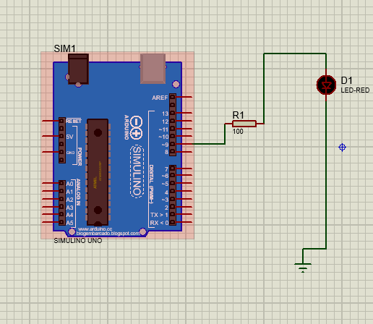

1. Mã Lệnh

|  |  |  |  |  |  |  |  |  |  |  |  |  |  |  |  |  |  |  |  |  |  |  |  |  |  |  |  |  |  |  |  |  |  |  |  |  |  |
| --- | --- | --- | --- | --- | --- | --- | --- | --- | --- | --- | --- | --- | --- | --- | --- | --- | --- | --- | --- | --- | --- | --- | --- | --- | --- | --- | --- | --- | --- | --- | --- | --- | --- | --- | --- | --- | --- |
| |  | | --- | | int brightness = 0 ; | |  |  | |  | void setup() { | |  | // put your setup code here, to run once: | |  | pinMode(9, OUTPUT); | |  | } | |  |  | |  | void loop() { | |  | // put your main code here, to run repeatedly: | |  | for( brightness = 0; brightness <= 255; brightness +=5) { | |  | analogWrite(9, brightness); | |  | delay(30); | |  | } | |  | for (brightness = 255; brightness >= 0 ; brightness -=5) { | |  | analogWrite(9, brightness); | |  | delay(30); | |  | } | |  |  | |  | } | |

Bài 4. LED sáng dần từ LED số 1 – 10

1. Mô tả

* Sau khi cấp nguồn điện, LED sẽ sáng lần lượt từ led số 1 đến led số 10 và ngược lại

1. 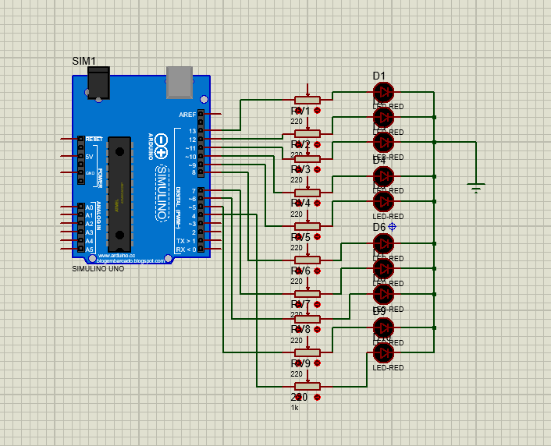Sơ đồ mạch
2. Mã lệnh

|  |  |  |  |  |  |  |  |  |  |  |  |  |  |  |  |  |  |  |  |  |  |  |  |  |  |  |  |  |  |  |  |  |  |  |  |  |  |  |  |  |  |  |  |
| --- | --- | --- | --- | --- | --- | --- | --- | --- | --- | --- | --- | --- | --- | --- | --- | --- | --- | --- | --- | --- | --- | --- | --- | --- | --- | --- | --- | --- | --- | --- | --- | --- | --- | --- | --- | --- | --- | --- | --- | --- | --- | --- | --- |
| |  | | --- | | byte ledPin[] = {4, 5, 6, 7, 8, 9, 10, 11, 12, 13}; | |  | int direction = 1; | |  | int currentLED = 0; | |  | void setup() { | |  | for (int x = 0; x < 10; x++) { | |  | pinMode(ledPin[x], OUTPUT); | |  | } | |  | } | |  | void loop() { | |  | for (int x = 0; x < 10; x++) { | |  | digitalWrite(ledPin[x], LOW); | |  | } | |  | digitalWrite(ledPin[currentLED], HIGH); | |  | currentLED += direction; | |  | if (currentLED == 9) { | |  | direction = -1; | |  | } | |  | if (currentLED == 0) { | |  | direction = 1; | |  | } | |  | delay(500); | |  | } | |

Bài 5. LED RGB

1. Linh kiện
2. Mô tả

* Sau khi cấp nguồn điện chạy vào, đèn RGB sẽ sáng nhiều màu khác nhau liên tiếp

1. Sơ đồ mạch

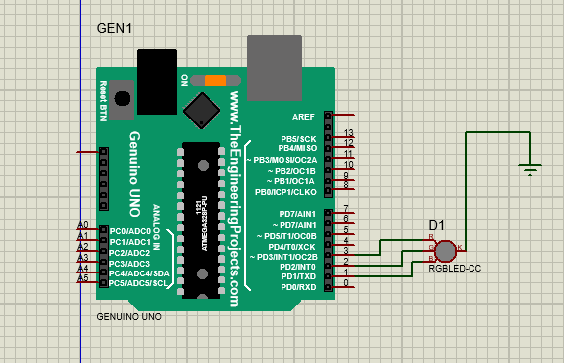

1. Mã lệnh

|  |  |  |  |  |  |  |  |  |  |  |  |  |  |  |  |  |  |  |  |  |  |  |  |  |  |  |  |  |  |  |  |  |  |  |  |  |  |  |  |  |  |  |  |  |  |  |  |  |  |  |  |  |  |  |  |  |  |  |  |  |  |  |  |  |  |  |  |  |  |  |  |  |  |  |  |  |  |  |  |  |  |  |  |  |  |  |  |  |  |  |  |  |  |  |  |  |  |  |  |  |  |  |  |  |  |  |  |  |  |  |  |  |  |  |  |  |  |  |  |  |  |
| --- | --- | --- | --- | --- | --- | --- | --- | --- | --- | --- | --- | --- | --- | --- | --- | --- | --- | --- | --- | --- | --- | --- | --- | --- | --- | --- | --- | --- | --- | --- | --- | --- | --- | --- | --- | --- | --- | --- | --- | --- | --- | --- | --- | --- | --- | --- | --- | --- | --- | --- | --- | --- | --- | --- | --- | --- | --- | --- | --- | --- | --- | --- | --- | --- | --- | --- | --- | --- | --- | --- | --- | --- | --- | --- | --- | --- | --- | --- | --- | --- | --- | --- | --- | --- | --- | --- | --- | --- | --- | --- | --- | --- | --- | --- | --- | --- | --- | --- | --- | --- | --- | --- | --- | --- | --- | --- | --- | --- | --- | --- | --- | --- | --- | --- | --- | --- | --- | --- | --- | --- | --- |
| |  | | --- | | void setup() { | |  | // put your setup code here, to run once: | |  | pinMode(3,OUTPUT); | |  | pinMode(2,OUTPUT); | |  | pinMode(1,OUTPUT); | |  | } | |  | const int B=0; | |  | const int R=1; | |  | const int G=2; | |  | const int Y=3; | |  | const int Bl=4; | |  | const int M=5; | |  | const int C=6; | |  | const int W=7; | |  |  | |  | void loop() { | |  | // put your setup code here, to run once: | |  | for(int i=B; i<=W; i++) | |  | { | |  | display(i); | |  | delay(500); | |  | } | |  | } | |  | void display(int colour_number) | |  | { | |  | switch(colour_number){ | |  | case B: digitalWrite(1,0); | |  | digitalWrite(2,0); | |  | digitalWrite(3,0); | |  | break; | |  | case R: digitalWrite(1,0); | |  | digitalWrite(2,0); | |  | digitalWrite(3,1); | |  | break; | |  | case G: digitalWrite(1,0); | |  | digitalWrite(2,1); | |  | digitalWrite(3,0); | |  | break; | |  | case Y: digitalWrite(1,0); | |  | digitalWrite(2,1); | |  | digitalWrite(3,1); | |  | break; | |  | case Bl: digitalWrite(1,1); | |  | digitalWrite(2,0); | |  | digitalWrite(3,0); | |  | break; | |  | case M: digitalWrite(1,1); | |  | digitalWrite(2,0); | |  | digitalWrite(3,1); | |  | break; | |  | case C: digitalWrite(1,1); | |  | digitalWrite(2,1); | |  | digitalWrite(3,0); | |  | break; | |  | case W: digitalWrite(1,1); | |  | digitalWrite(2,1); | |  | digitalWrite(3,1); | |  | break; | |  |  | |  | } | |  | } | |

Bài 6. Cảm biến nhiệt độ điều khiển độ sáng của LED

1. Mô tả

* Sau khi cấp nguồn điện, ta điều chỉnh nhiệt độ
* Nếu nhiệt độ trên 36 độ thì đèn sẽ sáng ngược lại đèn tắt

1. Sơ đồ mạch

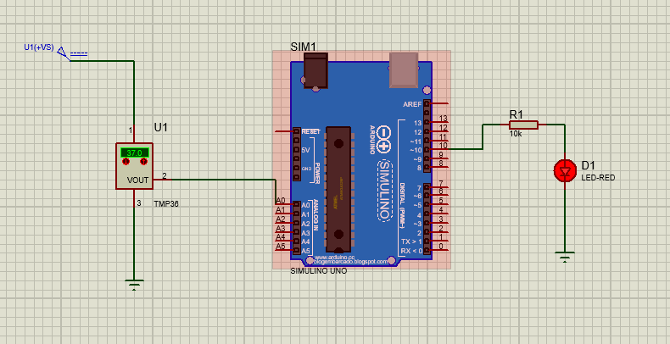

|  |  |  |  |  |  |  |  |  |  |  |  |  |  |  |  |  |  |  |  |  |  |  |  |  |  |  |  |  |  |  |  |  |
| --- | --- | --- | --- | --- | --- | --- | --- | --- | --- | --- | --- | --- | --- | --- | --- | --- | --- | --- | --- | --- | --- | --- | --- | --- | --- | --- | --- | --- | --- | --- | --- | --- |
| |  |  | | --- | --- | | void setup() { | | |  | // put your setup code here, to run once: | |  | pinMode(10,OUTPUT); | |  | Serial.begin(96000); | |  |  | |  | } | |  |  | |  | void loop() { | |  | // put your main code here, to run repeatedly: | |  | int x = analogRead(A0); | |  | int t = map(x, 0, 410, -50, 150); | |  | if(t>=36)digitalWrite(10, HIGH); | |  | else digitalWrite(10, LOW); | |  | delay(100); | |  |  | |  | } | |

1. Mã lệnh